

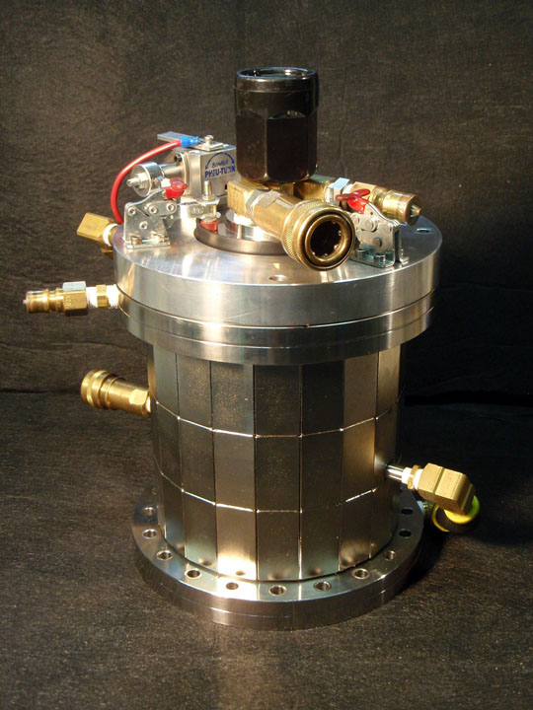
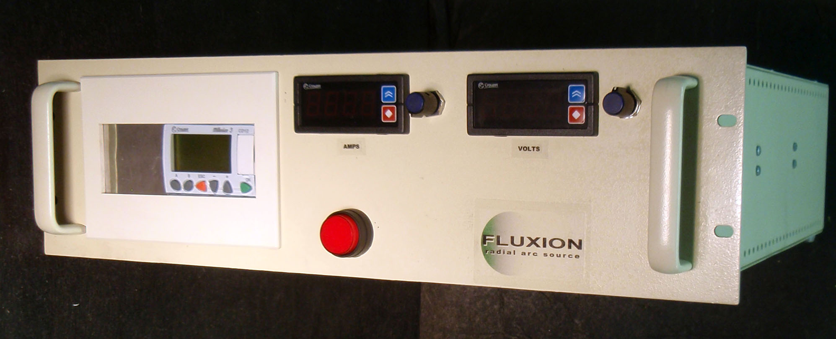
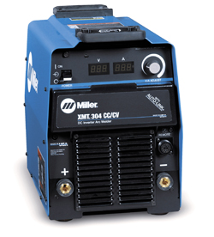
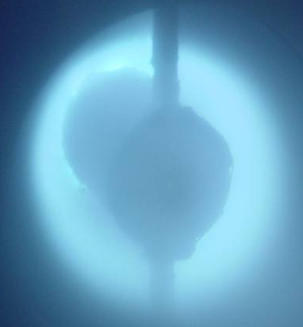
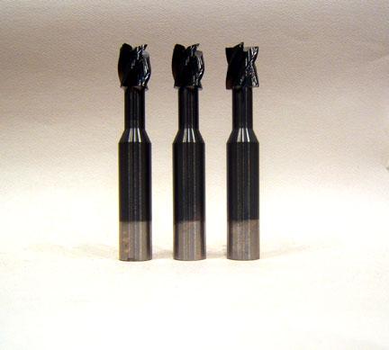

Radial Arc source on
200mm conflat flange.
Complete stand-alone system with control and power supply available.
The Radial Arc in operation.
ta-C coated tools
phone: 479.280.0036 email: info@fluxion-inc.com

web: www.fluxion-inc.com

The Radial Arc is a practical filtered cathodic arc source.
- Fully ionized, macroparticle-free, pure metal and carbon ion deposition.
- High rates comparable to unfiltered arc.
- Simple, compact, symmetrical, patented (US 6,756,596 and pending).
- Easy to operate and maintain. Uses all permanent magnets - no coils.
- Simple replacement for other sources including unfiltered-arc and sputtering.
- Inherent Uniformity (no beam scanning), over any length using multiple sources.
- Adjustable rate-distribution for uniformity on stationary or rotating substrates.
- Simple, inexpensive targets with long life and high usage that are easy to replace.
- Unmatchable adhesion, density, stoichiometry, hardness. High sp³ Hard-Carbon.
- Wear, corrosion, decorative, data storage, optical, semi-conductor applications.
Fluxion offers a range of solutions for your coating requirements: complete systems incorporating Radial Arc technology; individual sources; R&D and coating services. We look forward to speaking with you about your application.

Radial Arc
Info Sheet

